How to launch the program:

from command line:

> java -jar utl.jar diagram.graphml [output.txt]

diagram.graphml is the file exported from yEd and represents the UML class diagram;
UML output.txt is the file where the FOL/DL formulae will be saved. If it is ommitted, the output will be printed on screen.

How to design diagrams using yEd

Class
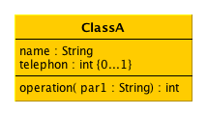
There is an example of a UML class named ClassA with two attributes and one operation. There are no differences between standard UML and this formalism. The first attribute with signature “name : String” has name “name” and domanin “String”. The second attribute has multiplicity more. In the end we can see an example of an operation with one parameter.

Association

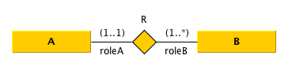
This is an example of an binary association with multiplicity, roles, and name. Notice, we have introduced a diamond node instead using a normal edge between the classes. The node is labeled with the name, and the two edges labeled with the roles and the multeplicity.

Generalization
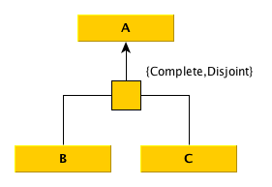
A generalization is like UML standard with a rectangle node among the classes. Notice that, the edges between the children classes and the rectangle node sould be normal, and the edge the goes to the class A is arrowed.

Association subset

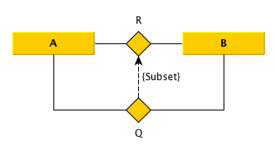
A subset between associations is an arrowed edge between the two diamond nodes. The label “{Subset}” is not mandatory, but belongs to UML.

Key constraint

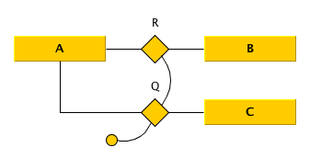
A key constraint, in this case between R and Q, is composed by an ellipse node connected, using arch shaped edges, to the association as shown in figure.

